PA4 Report

1. The running time of pa4 takes slightly longer the running time of PA4. However, the difference is not big. When I compared this two performance, there was 100 msec difference. The capacity of the request buffer doesn’t really affect the performance of the program. Therefore, I think it could be justified as a necessary trade-off.

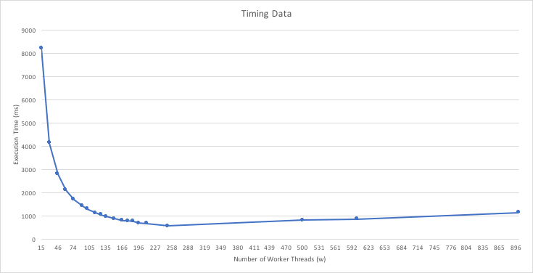

It shows the similar trend to the PA 3 code. As the worker thread increases the performance gets faster till it reaches to the maximum worker thread the code can hold. the graph showed the dramatic chnge at the beginning but then the change becomes smaller as it reaches to the maximum amount of worker thread.

I seem like the running time is decreased very slightly as the size of request buffer is increased. However, once the request buffer has enough size of some point, the running time does not get effected by the size of request buffer even though it grows.